 | EUROPEAN COMMISSION  DIRECTORATE-GENERAL  INFORMATICS  Information systems Directorate

European Commission
e-TrustEx Use Case Specification: Submit Configuration Notification

Date: | 08/05/2015
Version: | 1.000
Authors: | Anamaria Batrinu
Revised by: | Technical Review:  Quality Review:
Approved by:
Public:
Reference Number:

TABLE OF CONTENTS
1. Use-Case Description 3
2. References 3
3. Points of Extensions 3
3.1. Points of extension mapping 3
3.2. Document Type Code 4
3.3. Party Roles 4
3.4. Document Identifier 4
3.5. Document Issue Date 4
3.6. Synchronous XSD Validation 4
3.7. Synchronous Schematron Validation 4
3.8. Synchronous Specific Validation 4
3.8.1. Synchronous SLA Validation 4
3.8.2. Other specific validation 5
3.9. Synchronous Business Specific Processing 5
3.10. Asynchronous XSD Validation 5
3.11. Asynchronous Business Rules Validation 5
3.11.1. Asynchronous Schematron Validation 5
3.11.2. Asynchronous Parent-Child Relationship Validation 5
3.11.3. Reprocessing Timeframe for Parent Document 5
3.11.4. Asynchronous Specific Validation 5
3.12. Asynchronous Business Specific Processing 5
3.12.1. Human Readable Generation 5
3.12.2. SLA Policy Validation 5
3.12.3. Other specific processing 5
3.13. Availability Notification 5
3.14. State Machine 5
3.14.1. Transition to state Approved 6
3.14.2. Transition to state Rejected 6
3.15. Dispatching 6
4. Additional Information 6

Document History

Version | Date | Comment | Modified Pages
1.000 | 08/05/2015 | Creation | All

Use-Case Description
This Use Case describes the service that enables parties to send ConfigurationNotification document via electronic means using the e-TrustEx platform. It extends the generic use case UC1_002 Process Asynchronous Message to ConfigurationNotification document.

References
Document Title | Document Reference
UC1_002 Process Asynchronous Message | https://webgate.ec.europa.eu/CITnet/svn/ETRUSTEX/trunk/001 e-TrustEx/002 Requirements/Use Case Model/New Use Cases/UC1_002 Process Asynchronous Message.doc
Use Case eTrustex – Submit Application Response | https://webgate.ec.europa.eu/CITnet/svn/ETRUSTEX/trunk/001 e-TrustEx/002 Requirements/Use Case Model/New Use Cases/UC1_003 Submit Application Response Use Case Specification_2.0.doc
ConfigurationNotification XSD document | To be defined
ConfigurationNotificationSchematron rules document | N/A
Code List Document | https://webgate.ec.europa.eu/CITnet/svn/ETRUSTEX/trunk/001 e-TrustEx/003 Architecture/001 Data Model/000 Code Tables/EC_CodeList_e-TrustEx.xls
Human Readable Template | N/A

Points of Extensions

Points of extension mapping
Point of extension (in this document) | Extended point (in Asynchronous Use Case)
Document Type Code | Point of extension 2  Point of extension 4  Point of extension 9
Party Roles | Point of extension 1
Document Identifier | Point of extension 3
Document Issue Date | Point of extension 8
Synchronous XSD Validation | Point of extension 5
Synchronous Schematron Validation | Point of extension 6
Synchronous Specific Validation | Point of extension 7
Synchronous Business Specific Processing | Point of extension 17
Asynchronous XSD Validation | Point of extension 10
Asynchronous Schematron Validation | Point of extension 11
Asynchronous Parent-Child Relationship Validation | Point of extension 12
Reprocessing Timeframe | Point of extension 16
Asynchronous Specific ValidationError: Reference source not found | Point of extension 18
Data Extraction | Point of extension 13
Asynchronous Business Specific Processing | Point of extension 14
Availability Notification | Point of extension 19
Dispatching | Point of extension 15

Document Type Code
The document type code for ConfigurationNotification is CFN and it is defined in Code List Document, under the sheet DocumentTypeCode.

Party Roles
The ConfigurationNotification document must be sent by a Party having ConfigurationPublisher Role and received by a Party having ConfigurationSubscriber Role.

Document Identifier
The document identifier can be found via the following Xpath expression:
\\ConfigurationNotification\cbc:ID

Document Issue Date
The document issue date can be found via the following Xpath expression:
\\ ConfigurationNotification \cbc:IssueDate

Synchronous XSD Validation
N/A

Synchronous Schematron Validation
N/A

Synchronous Specific Validation

Synchronous SLA Validation
N/A

Other specific validation
N/A

Synchronous Business Specific Processing
N/A

Asynchronous XSD Validation
The document must be valid according to XSD documentConfigurationNotification.

Asynchronous Business Rules Validation

Asynchronous Schematron Validation
N/A

Asynchronous Parent-Child Relationship Validation
N/A

Reprocessing Timeframe for Parent Document
N/A

Asynchronous Specific Validation
N/A

Asynchronous Business Specific Processing

Human Readable Generation
N/A

SLA Policy Validation
N/A

Other specific processing
N/A

Availability Notification
N/A

State Machine
The following state machine shows the usual (generic) states that are Submitted, Received and Error. Beside these states some specific states are displayed in blue: Approved and Rejected.

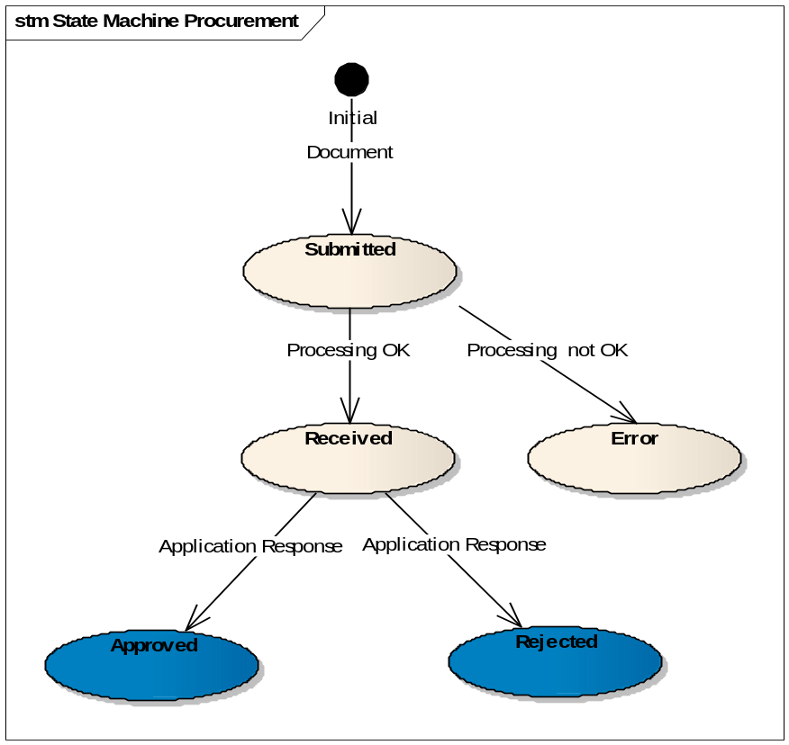

Transition to state Approved
At this point, the Use Case Submit Application Response is included.
When an application response referencing an existing ConfigurationNotification document in state received arrives in the system with a response code CFN:1 the state of the ConfigurationNotification document becomes Approved.

Transition to state Rejected
At this point, the Use Case Submit Application Response is included.
When an application response referencing an existing ConfigurationNotification document in state received arrives in the system with a response code CFN:2 the state of the ConfigurationNotification document becomes Rejected.

Dispatching
The following routing rules are used for dispatching the message:
Not a general rule for configuration notification, there can be specific routing configurations for notifications depending on subscriber.

Additional Information
N/A

